
Helping disabled people to vote: easy read

Contents

About this document 2
About us 3
Introduction 4
What stops people from voting? 4
Equipment to help people to vote 5
Deciding what equipment to have in polling stations 7
Training 8
Letting people know 9
Working with other organisations 10
What worked well 11
Words used in this easy read 12

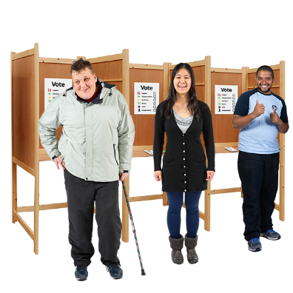
About this document

This easy read document is about what Returning Officers should do to help disabled people to vote at a polling station.
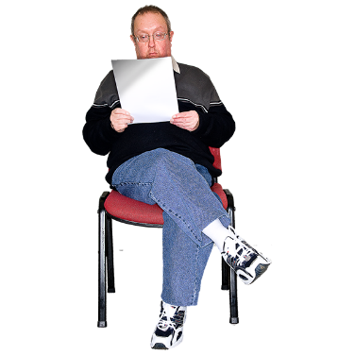

Read the non-easy read version of the information for Returning Officers.

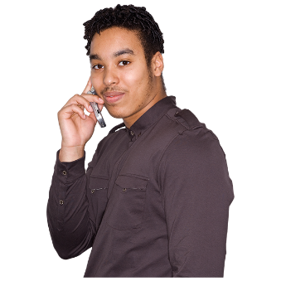
If you have any questions about this document or the information for Returning Officers, you can phone us on 0333 103 1928.


We used the words ‘disabled people’ in this document because people are disabled by what is around them.

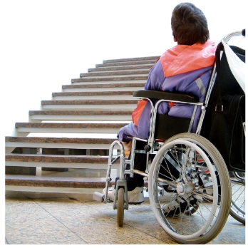
For example, someone who uses a wheelchair is disabled if there are steps to get into a building.
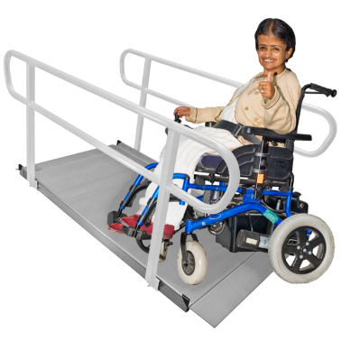
The same person is not disabled if there is a ramp to get into the building.

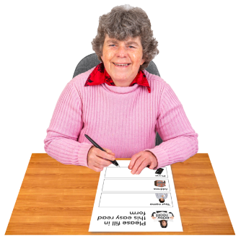

There is an easy read survey about the information in this document.



Read and take part in the survey.

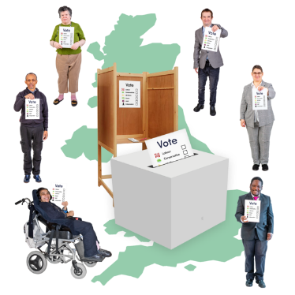
About us

We are the Electoral Commission. The Electoral Commission is in charge of elections in the UK.



Find out more on the Electoral Commission website.

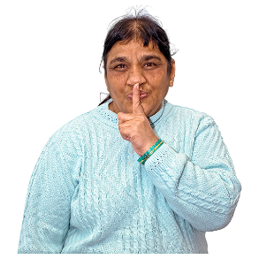
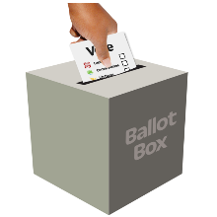
Introduction

Everyone should have the right to vote independently and secretly.

Disabled people might need extra help or equipment so they can vote independently and secretly.

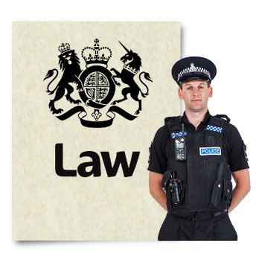

There are laws which say that Returning Officers have to help disabled people to vote.

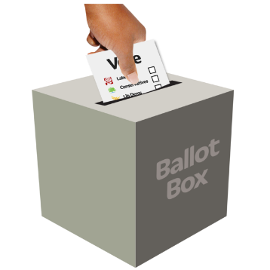
What stops people from voting?


There are lots of things that stop people from voting.


For example:
- voting is too difficult
- people do not know they can ask other people to help them to vote
- people are nervous about going to the polling station
- it can be hard to get into the polling station

Equipment to help people to vote

All polling stations should have equipment to help people to vote independently and secretly.

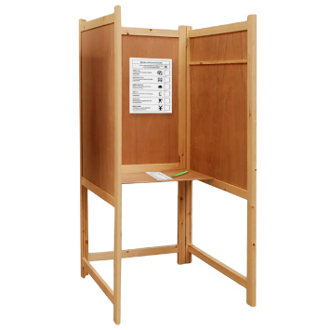
All polling stations must have:
- a poster in each polling booth telling people how to fill in their ballot paper
- ballot papers in large print


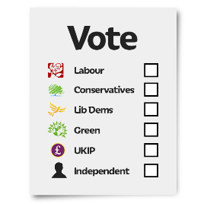
You can look at the large print ballot paper, but you can not fill it in.

If you used the large print ballot paper to vote, you would not be voting secretly because everyone would know it was your ballot paper.


Returning Officers have a list of equipment that can help disabled people to vote.

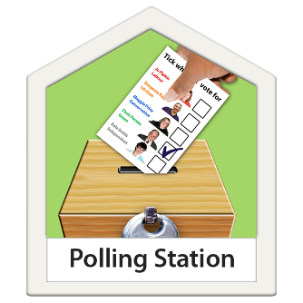


The list includes equipment that should be at every polling station.

For example:


- a chair or some seats
- magnifiers to make text bigger
- a polling booth at wheelchair height
- staff name badges
- ramps if there are steps

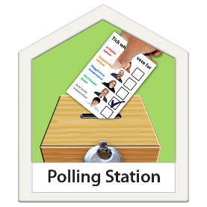
The list includes equipment which might be at a polling station.
?

For example:

- hearing induction loops to help people who have hearing loss
- audio devices to help people who have sight loss
- easy read information


Deciding what equipment to have in polling stations

Returning Officers have to decide what equipment to have at each polling station.

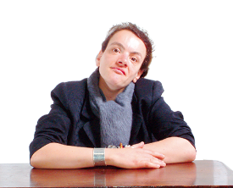
Returning Officers should be able to say how they have decided what equipment to have.

If someone asks for some equipment to be at a polling station, the Returning Officer has to think about if they will provide it.

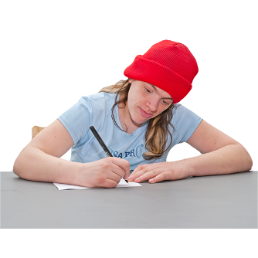
Returning Officers have to write down why they have decided not to have any equipment that someone has asked for.

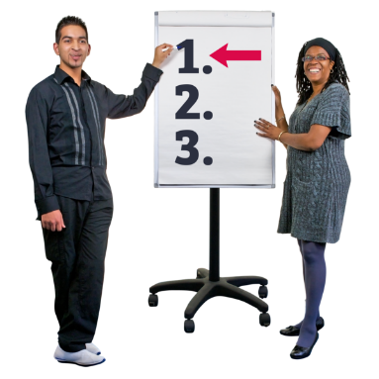
Training

Staff at polling stations should have training so they know how to help disabled people to vote.



We have information on our website and on YouTube which can help to train staff.

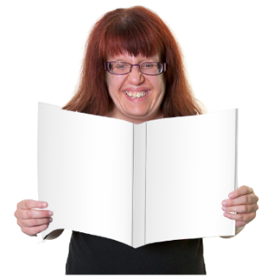

We also give information to the Returning Officers which they can use to help with the training.

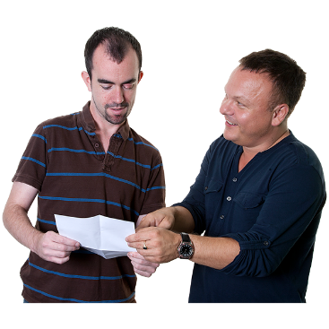
Letting people know

Returning Officers should let people know what will happen at the polling station and what support they can have.

Returning Officers should let disabled people know what help there is so they can vote independently and secretly.

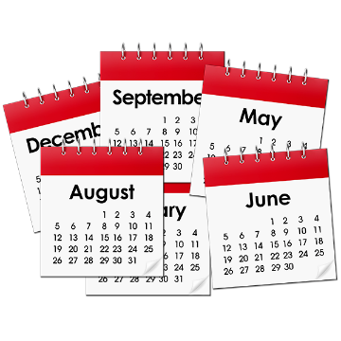

Returning Officers should think about giving people information at all times of the year, not just before an election.
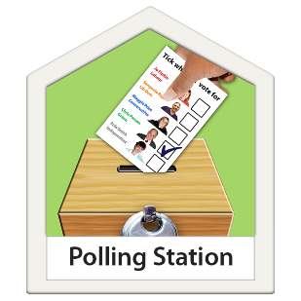

They could tell people:
- where their polling station is
- how they can get help to vote

They could:
- send information in different formats
- share example ballot papers


Working with other organisations

Returning Officers should work with local organisations.

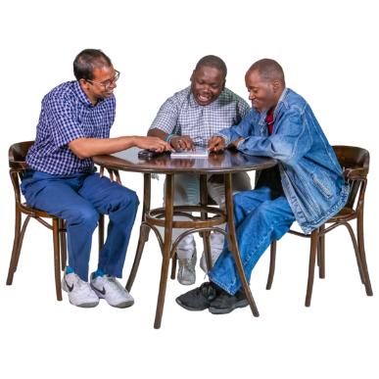

The local organisations can help Returning Officers work out what help disabled people might need.

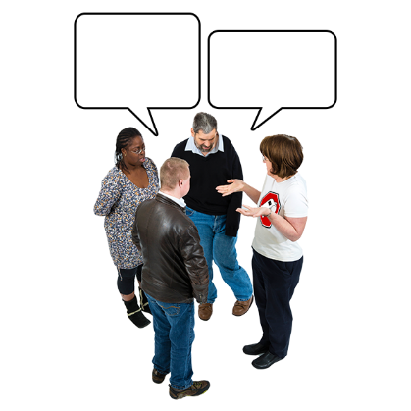

The local organisations can let people know what help they can have.

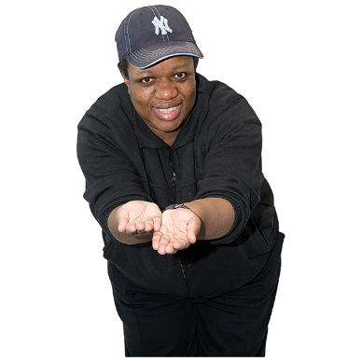

The local organisations might have equipment that the Returning Officers can borrow to help disabled people to vote.

What worked well

After each election, Returning Officers should look at what help disabled people had to help them to vote at polling stations.

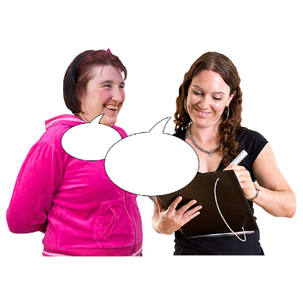
Returning Officers could ask people who voted, local organisations and polling station staff about what worked well and what could be changed to help disabled people to vote.

Words used in this easy read
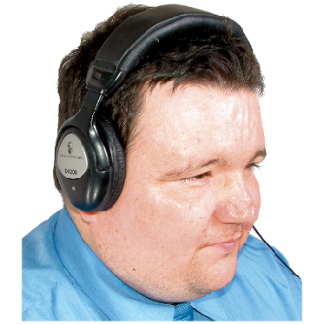
audio devices Machines which let you listen to information so you do not have to read.

ballot paper The piece of paper you fill in to vote.

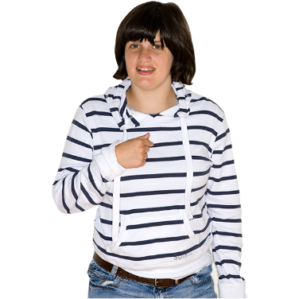

independently To do something by yourself.

polling booth The part of the polling station where you fill in your ballot paper.

polling station The place you go to vote in an election.

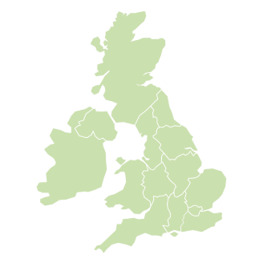
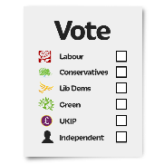
Returning Officers The people who are in charge of how elections are carried out in their area. In Northern Ireland, the Chief Electoral Officer is the Returning Officer.

secretly Voting secretly means no-one can see who you vote for.

Thanks to photosymbols

