
Questions about the information for Returning Officers: helping disabled people to vote

Contents

Introduction 2
What we did 4
What people said 5
Other things which people told us 10
What happens now? 11
How to let us know what you think 12
Questions about the information for Returning Officers 14
About you 20
Contact details 21
Words used in this easy read 23

Introduction
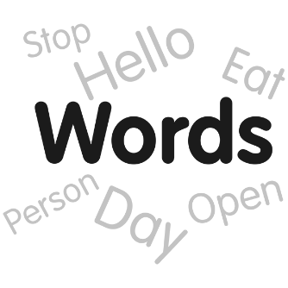
We used the words ‘disabled people’ in this document because people are disabled by what is around them.
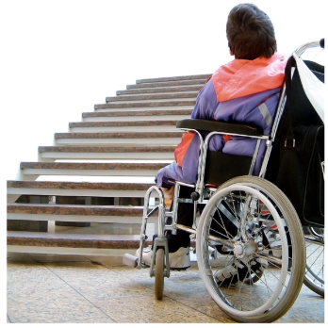

For example, someone who uses a wheelchair is disabled if there are steps to get into a building.

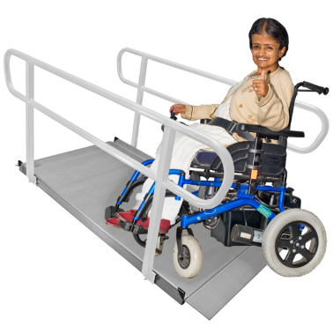

The same person is not disabled if there is a ramp to get into the building.

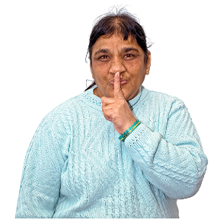
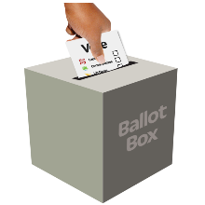

Everyone should have the right to vote independently and secretly.

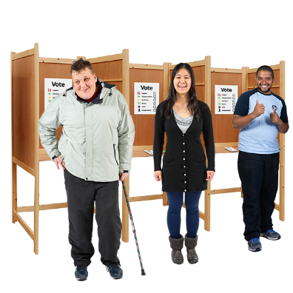
Disabled people might need extra help or equipment so they can vote independently and secretly.
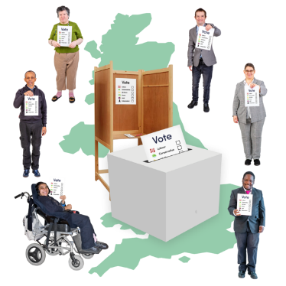
The Electoral Commission is in charge of elections in the UK.

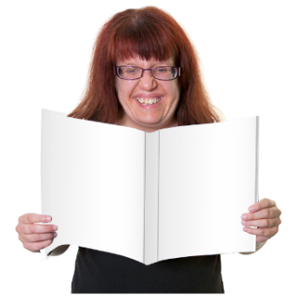


The Electoral Commission makes information for Returning Officers.

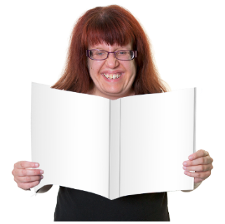


We want to know if the information tells Returning Officers what they need to know about helping disabled people to vote at polling stations.


Find out more on The Electoral Commission website.

What we did
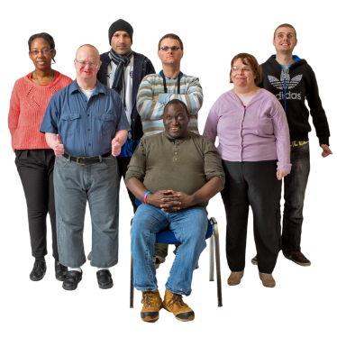
We talked to lots of people, charities and groups about the things that make it difficult for disabled people to vote at polling stations.

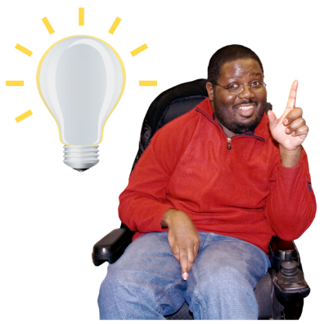

We asked them to tell us how to make it easier for disabled people to vote.

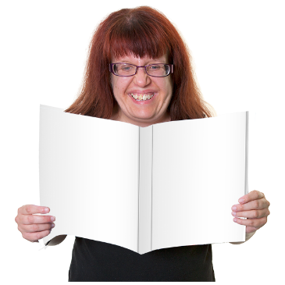


We used what people told us to write some information for Returning Officers.

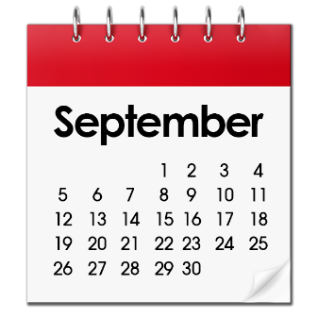

In September 2022, we asked people to let us know what they thought about the information.

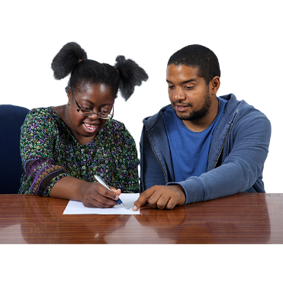
What people said

We looked at what people said and made some changes to the information for Returning Officers.

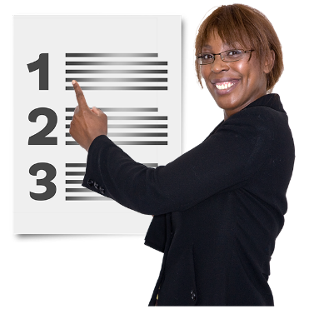

Here are some examples of the changes we made.

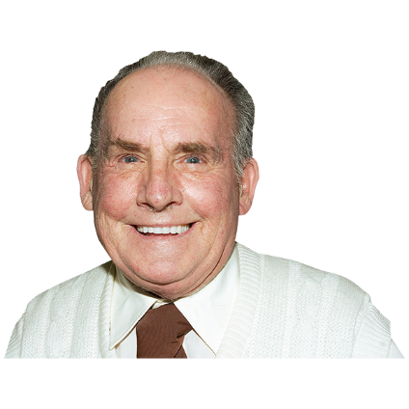

We added hidden disabilities as a reason why some people might find it difficult to vote.

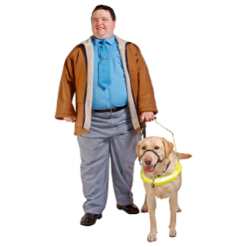
Our information about training for polling station staff now includes:

- assistance animals
- equipment that people with sight loss might use to help them to vote
- text to speech apps

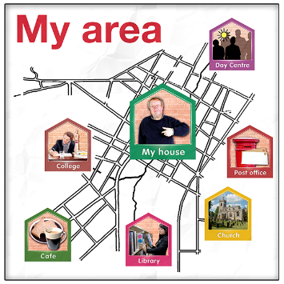
We added extra information about how Returning Officers might make changes to help people in their area.



We added extra information about the equipment that it is a good idea to have at the polling station.

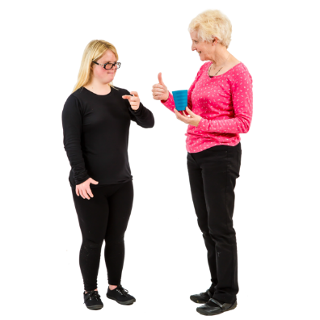

We added Makaton to the list of ways in which information could be provided at the polling station.


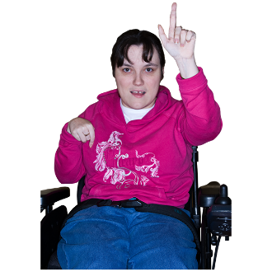

People asked us who will pay for the equipment at polling stations.



Returning Officers will be able to apply for funding to pay for the equipment.
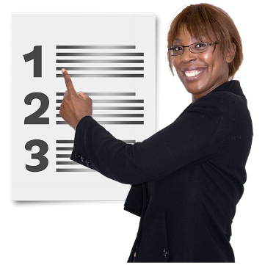
Several people asked us to tell Returning Officers what equipment they must have in their polling station.

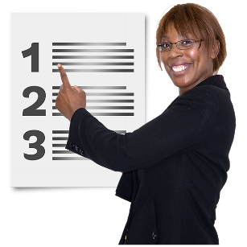


We can not tell Returning Officers what equipment they must have.

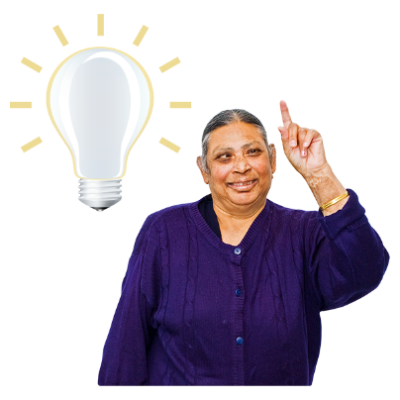

We can say what equipment it is a good idea to have.

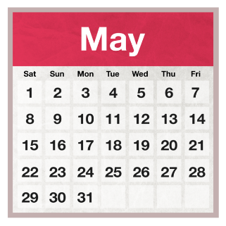

Before the elections in May 2023, we will try to:


- make information that Returning Officers can use on social media and websites
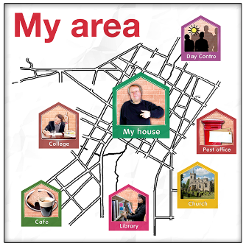
- make information that Returning Officers can use to contact disability groups and people in their area


- work with local councils so they can tell people about the help and information we have on our website

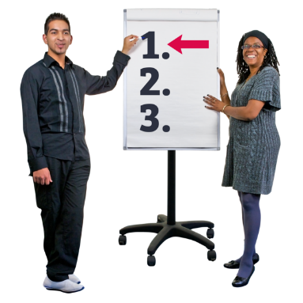

- work with national organisations to make training information for Returning Officers




- help to make sure that polling stations have information in different formats

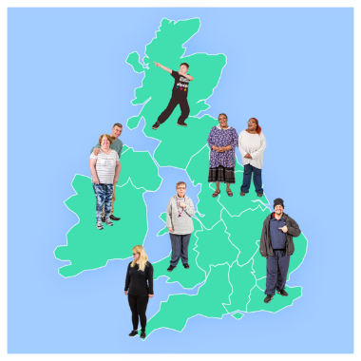
- work with disability organisations across the UK so that we can give them information to pass on to the people they know



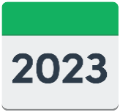
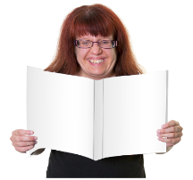

We will look at, update and add to our information and support each year.



Several people said we should give more information to help Returning Officers to work out what went well at an election.

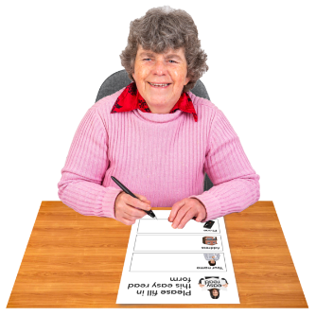
We will make a survey that Returning Officers can use with people who needed extra help to vote.

People who take part in the survey can say how easy or difficult it was for them to vote and what they think about the extra help they had.

Some people asked us to share examples of how disabled people were helped to vote.


We will include examples in our reports.



We will share the reports with other local councils to help them to plan how to help disabled people to vote.

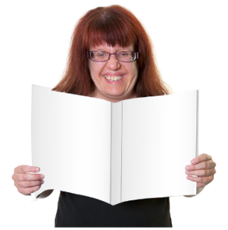

Other things which people told us

Some people told us about things which are not in the information for Returning Officers,

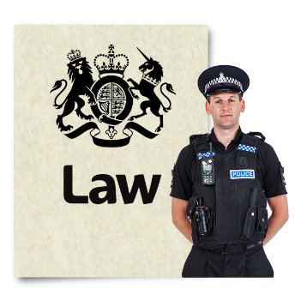

or would need the law to be changed.

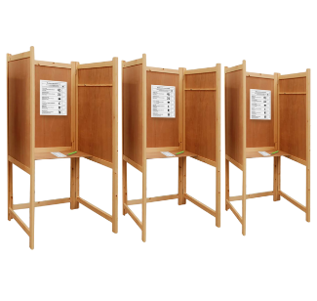
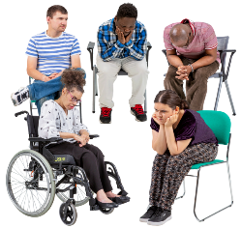
For example:
- finding it difficult to vote because of your religion
- finding it difficult to vote because you do not speak English
- making voting by post easier
- providing letters and poll cards in other formats

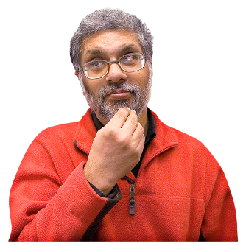

We will think about how we can help people with these things.

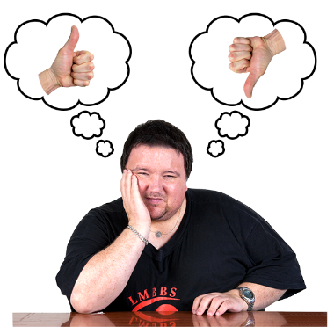
What happens now?

We want to know what you think about our updated information for Returning Officers.

Read the updated information for Returning Officers.



There is also an easy read guide to the information for Returning Officers.
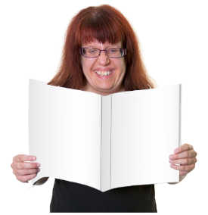

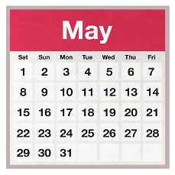
We will look at what people think and write some information to help Returning Officers get ready for the May 2023 elections.

How to let us know what you think

This is the easy read version of the questions about the information for Returning Officers.

You can find other versions of the questions on our website.

You can also:

- answer the questions online (not in easy read). If you answer the questions online, you can not save your answers and come back to them later.

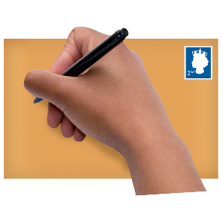
- write to us at:
Electoral Administration Guidance Team
The Electoral Commission
3 Bunhill Row London EC1Y 8YZ

- email EAConsultation@electoralcommission.org.uk

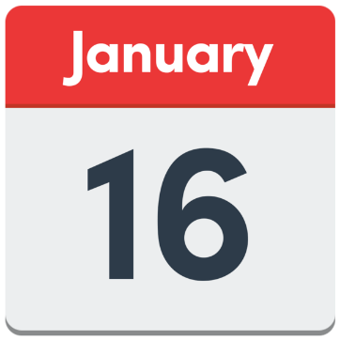

You need to let us know what you think by Monday 16th January 2023.

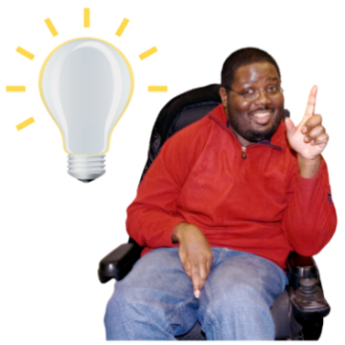

If you answer ‘No’ or ‘Don’t know’, please let us know what you think we should change when we update the information again.

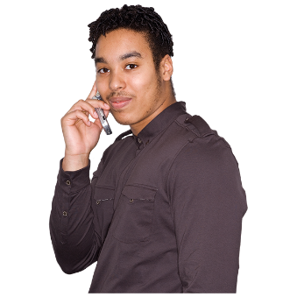
If you have any questions about the information for Returning Officers, or need help to answer the questions in this survey, please phone us on 0333 103 1928.

Questions about the information for Returning Officers

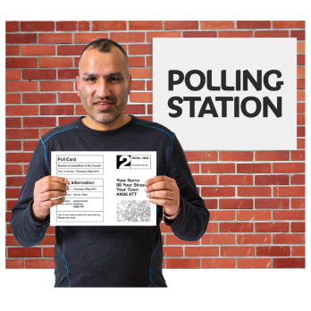
Question 1: Things which make it difficult for disabled people to vote
Lots of things can make it difficult for disabled people to vote at a polling station.

Is there enough information for Returning Officers about the things which might make it difficult for disabled people to vote at a polling station?



Yes
No
Don’t know


If you answered no, please tell us what other information we should add.

Question 2: Helping Returning Officers to make it easier for disabled people to vote at a polling station
Information and equipment can sometimes help disabled people to vote independently and secretly.

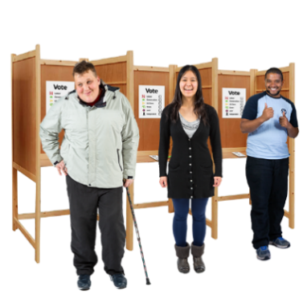
Do you think the updated information and extra resources are enough to help Returning Officers support disabled people to vote independently and secretly at polling stations?

Yes

No
Don’t know

If you answered no, please tell us what other information we should add.

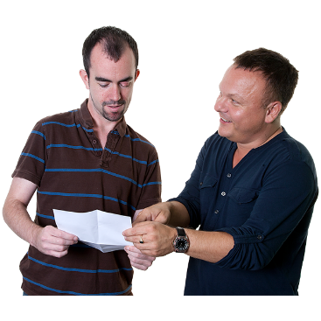
Question 3: Letting people know
Returning Officers should let disabled people know what will happen at the polling station and what support they can have.


We are going to do extra work with other organisations.

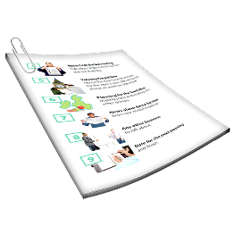
We are going to make some resources which Returning Officers can use.

Will the extra work and the resources help disabled people to understand what will happen at the polling station and what support they can have?

Yes
No
Don’t know

If you answered no, what other things do we need to make and do?

Question 4: What worked well?
After each election, Returning Officers should look at what worked well to help disabled people to vote.
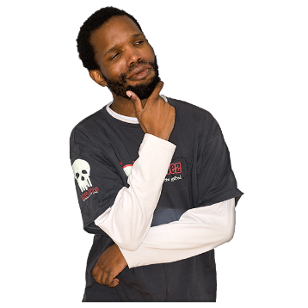

Returning Officers should also think about what could be changed to make it easier for disabled people to vote.

Do the new resources and updated information give the Returning Officers everything they need to look at what went well and what could be changed to make it easier for disabled people to vote?
Yes

No
Don’t know

If you answered no, what other information or resources do they need?


Anything else?
If you have anything else you would like to say about the updated information for Returning Officers, please write it in the box below.

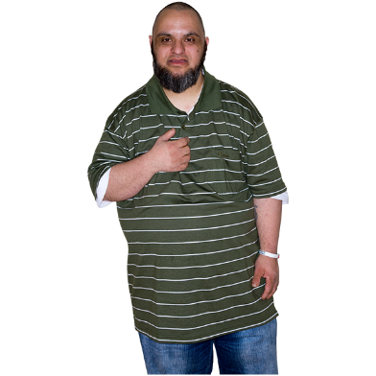
About you

Please tick the box which describes you. If you are answering the questions for someone else, please tick the box which describes them.

Member of the public
Returning Officer
Electoral Registration Officer
Electoral administrator
Charity or third sector organisation
Public body
Trade association or representative body
Government department
Political party
Political campaign group
Current holder or prospective holder of elected office
Private business
Other

If you chose other, please let us know more in the box below.

Contact details

If you would like to let us know your name and email address or phone number, please write them in the boxes below.

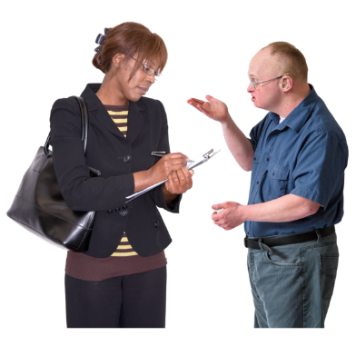
If you give us your name and email address or phone number, we might contact you about the answers you have given in this survey.

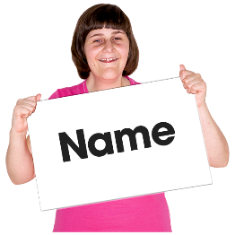
Your name

Email address

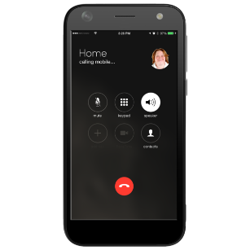
Phone number

Words used in this easy read
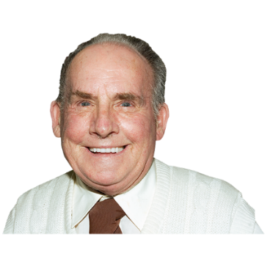
hidden disabilities Disabilities you can not see when you look at a person. For example, you can not always see that a person has anxiety or autism when you look at them.


independently To do something by yourself.

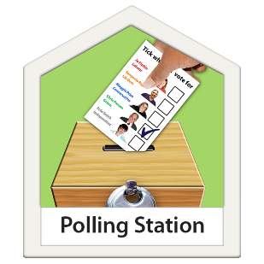

polling station The place you go to vote in an election.


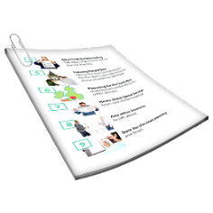
resources Things which people can use to help them. In this document, some of the resources are lists and surveys.

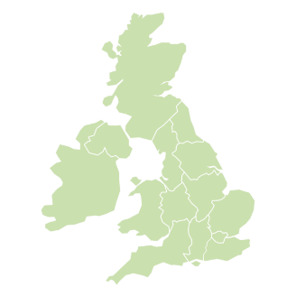
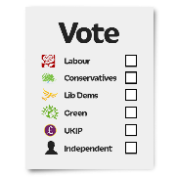
Returning Officers The people who are in charge of how elections are carried out in their area. In Northern Ireland, the Chief Electoral Officer is the Returning Officer.

secretly Voting secretly means no-one can see who you vote for.

Thanks to photosymbols

