Supporting care home residents in Wales to vote
Introduction
This document provides guidance on how you can support those in your care to register to vote.
Visit www.electoralcommission.org.uk/voter or call 0333 103 1929 for more information.
The electoral services team at your local council can provide support with the registration process. Find their contact details by entering your postcode on our website https://www.electoralcommission.org.uk/i-am-a/voter/your-election-information.

Key Principles
- Everybody who is eligible should be registered to vote, irrespective of any illness or disability they may have
- There should be a presumption that a person has capacity to register to vote
- Only the applicant, or a person to whom they have given power of attorney, can make the required declaration as part of an application for registration

Registering to vote
You can check the registration deadline for upcoming elections on our website.
Anyone who wants to vote in the UK must first be registered to vote. If they have registered before, they only need to register again if they have:
- moved house or,
- changed their name or nationality
If the person you are supporting has a permanent address, they can register online at https://www.gov.uk/register-to-vote or by completing a ‘Register to vote’ form. Some Electoral Registration Officers will also offer to take registration applications by telephone. You should contact your local electoral registration office for more information.
You may be supporting some residents who are using your service for a respite stay. In that case, you should check if they would like support to register to vote or find out if they have made alternative arrangements to register to vote at their home address.
Applicants must provide their date of birth and National Insurance number as part of their application. These details will be checked against official records to verify the identity of the person making the application. You may need to make extra effort to obtain this information, such as contacting a relative.
If this identifying information cannot be provided, applicants must give the reason why they cannot provide the information. They will then be contacted and asked to provide alternative documentary evidence of their identity. More information on accepted additional evidence can be found on our website.
The application requires the person who is applying to declare that the information provided is true (a ‘declaration of truth’). On the online application, the applicant must confirm that the information is correct. If the applicant elector has a physical disability that means they cannot write or type, you can assist them by typing on their behalf, as long as the elector is present and can communicate that the information provided on the application is true.

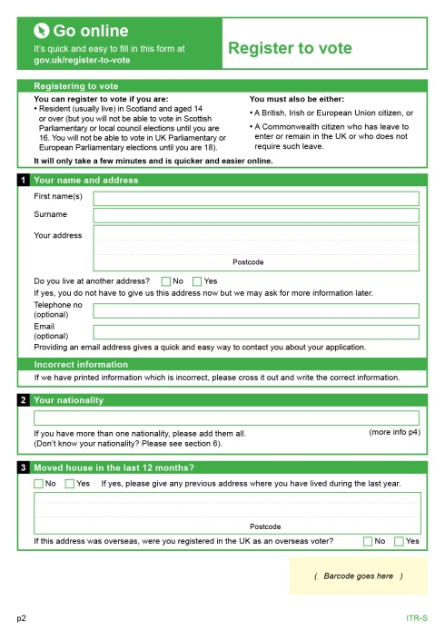
On the paper form, the applicant must make the declaration by signing or making their usual mark. Alternatively, a person who has an appropriate power of attorney can make the declaration on behalf of the applicant.

Power of attorney
Although you may provide assistance to a resident to help them to register themselves you cannot make the declaration of truth on their behalf. However, a person with an appropriate power of attorney may complete a registration application and make the declaration of truth on behalf of an incapacitated person.

What someone with a power of attorney can and can’t do on behalf of an applicant
A person with an appropriate power of attorney may complete a registration application and make the declaration of truth on behalf of someone who is unable to so themselves. This is because registering to vote is not the same as voting. However, they cannot vote on behalf of another person, as the law does not allow anyone to make voting decisions for someone else, even if they have power of attorney.
The Electoral Registration Officer must be satisfied that the person acting on the resident’s behalf holds a valid power of attorney, and that it covers making a registration application. A certified copy of the power of attorney may be requested where the Electoral Registration Officer considers it appropriate.

Annual canvass
Pre-populated | Blank
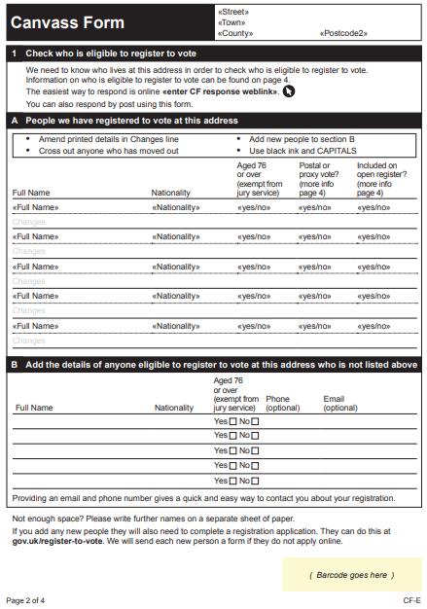 | 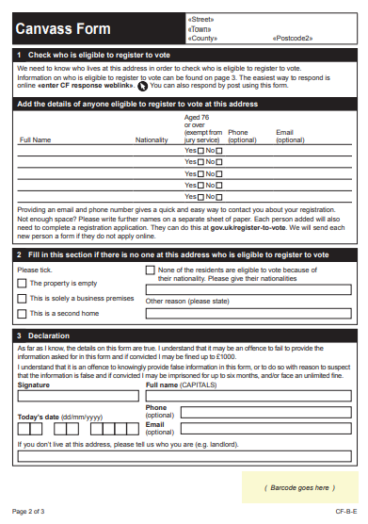
Electoral Registration Officers conduct the annual canvass of care homes in one of two ways:
- they may contact a responsible person, and request that they provide a list of the residents at the care home and other required information, or
- they may send a canvass form to the property
The purpose of the annual canvass is simply to capture information on who lives at the property to show who should and shouldn’t be registered to vote – a person cannot register to vote via a canvass communication.
A person in charge of the premises must provide the required information ensuring that all eligible people are listed. The form explains who is eligible to vote.
The canvass form may be sent blank or may be pre-printed with the names of people who are currently listed on the electoral register at that address.
- If the form is blank, the details of everyone eligible to register to vote must be added. Use their full names, e.g. ‘Elizabeth’ not ‘Bessie’. Include all residents even if they are physically or mentally frail. Once the form is processed, the local electoral registration office will send those people included on the form a ‘Register to vote’ form.
If the form is pre-printed it will list the names of the people who are currently on the electoral register at that address. It will also indicate whether these individuals have an existing postal or proxy vote, their open register preference and whether they are aged 76 or over (required for jury service purposes). Any person who is no longer resident should be crossed through, and anyone not listed who is eligible should be added. Once the form is processed, the local electoral registration office will send any new people a ‘Register to vote’ form.

How can I help the people in my care?
It is important that you do not make an assumption about an individual’s capacity to register or to vote or apply a “one size fits all” approach to all residents. Everyone, regardless of their capacity, should be registered to vote. It is important that vulnerable people do not lose their right to vote.
Suggested actions
- Ensure that any forms received are completed and returned promptly to avoid reminders
- Contact the local electoral registration office in the event of a resident’s death or if residents move in or out
- Provide information and assistance on the different ways in which residents may register and vote
- Provide scheduled transportation, if possible and appropriate, to and from polling stations
- Assign a member of staff as a single point of contact or ‘registration champion’

Voting by post
If a person would prefer to vote by post or won’t be able to make it to the polling station on polling day, they can apply to vote by post. More information about postal voting is available here: Apply to vote by post | Electoral Commission
Postal vote applications can also be completed online for some elections at https://www.gov.uk/apply-postal-vote or via a postal vote application form. If a person is unable to sign or to provide a consistent signature, they may contact their local electoral registration office to request an application for a signature waiver.
The postal ballot paper will be accompanied by a postal vote statement on which the resident must provide their signature and date of birth. You can help with this, but the resident must sign the postal vote statement themselves (unless they have been granted a waiver). You can help place the ballot paper (without looking at how it has been marked) into the correct envelope ensuring that their vote remains secret.
You must ensure that residents with postal votes have privacy while they are marking their ballot paper. It is very important that the resident marks their own ballot paper.
Voting by proxy
If a person won’t be able to make it to the polling station on polling day, they may be able to apply to vote by proxy, where they choose someone they trust to go to their polling station or polling place on their behalf. More information about proxy voting is available here: Apply to vote by proxy | Electoral Commission

Voting in person
When someone arrives at the polling station, a member of staff will:
- Ask them for their name and address so they can find them on the electoral register
- *At UK Parliament or Police and Crime Commissioner elections only* Ask for their photo ID, and check if it is acceptable
- Give them their ballot paper and direct them to complete it at a polling booth as usual
Voter ID

Photo ID is not required at Senedd elections, or local council elections and by-elections in Wales.
The following elections require photo ID to vote in person:
- UK Parliament general elections
- UK Parliament by-elections and recall petitions
- Police and Crime Commissioner elections
More information about Voter ID is available here: Voter ID | Electoral Commission

Support at the polling station
All voters have the right to vote independently and in secret. Some assistive equipment will be available at the polling station to help people to do so. Polling station staff are there to help, and voters should be encouraged to ask a member of staff if they have any questions or need assistance.
If someone has particular access needs, they can contact the local council to find out what assistive equipment will be available and request any additional equipment they feel they need. The council will decide whether the requested equipment can be provided.
The Presiding Officer can help the voter cast their vote if they would find this helpful. People who feel they cannot vote at a polling station without assistance, including disabled people, can also bring a companion with them to help them. Polling station staff should be informed if a companion is supporting someone to vote when they arrive.
If someone you are supporting experiences any issues at the polling station and wants to provide feedback about their experience, they should contact their local council.

Section 1 of the Mental Capacity Act 2005.

