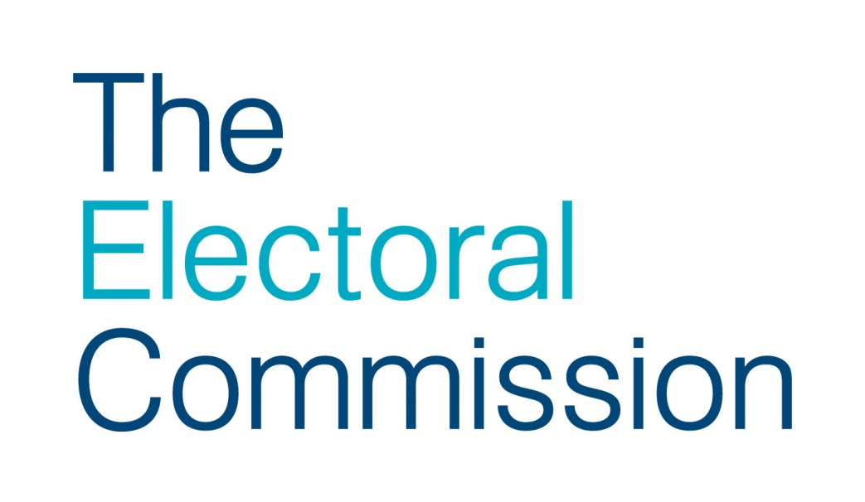

FAQs: postal vote identifier rejection notices
The following are designed to support you with responding to a range of potential questions you may receive from electors following the sending out of postal vote identifier rejection notices. It will be for you to decide which of these questions you would like elections staff to answer and which ones you are happy for others, such as call centre staff, to provide a response to.
1. I know I completed my postal vote as instructed – my postal vote has been wrongly rejected
By law, the Returning Officer has to check the signature and date of birth on every returned postal voting statement and determine whether they match those held on record. Where they do not, or where they are not provided, the Returning Officer must reject the postal vote. The Returning Officer’s decision is final. To avoid losing out in future:
Where the rejection is a result of the signature not matching | Where the rejection is a result of the date of birth not matching | Where the rejection is a result of the date of birth and/or signature being absent
If you have received one, make sure that you complete the signature refresh form and provide a fresh copy of your signature by no later than [insert date]. | Make sure that next time you include your date of birth, in the correct format, on the postal voting statement. The date of birth must be the same as the one given on the application.  Go to number 9 if they suggest that they may have given the wrong date of birth on their application. | Make sure that you provide your date of birth and signature next time. Make sure you follow the instructions and complete all of the required information.

2. Why was my postal vote was rejected due to not being delivered in accordance with the postal vote handling rules?

Postal vote handling rules only apply to UK Parliamentary elections, Police and Crime Commissioner elections, and local government and mayoral elections in England.
It was rejected because either:
- a postal vote return form was not completed
- the individual who returned my postal vote returned more than the permitted number
- the postal vote was handed in by a political campaigner who was not a close relative or person providing care
There are new rules to limit how many postal votes can be hand delivered to the RO, including restrictions on who the individual handing in the postal votes can be.
When a postal vote is handed in at a polling station or council office, the person handing them in must complete a form. If this form is not completed, the information is incomplete, or if the postal votes are just left behind, the postal vote(s)will be rejected.
An individual can hand in:
- their own postal vote
- as well as postal votes for up to five other people
If the individual confirms that they are a political campaigner or you have good reason to suspect they are one, there are additional restrictions on their handling postal votes.
Political campaigners can only hand in:
- their own postal vote
- and up to five others who are either close relatives or someone for whom they or the organisation which employs or engages them, provides regular care.
A Political campaigner is:
- a candidate at the election;
- an election agent of a candidate at the election;
- a sub-agent of an election agent at the election;
- employed or engaged by a person who is a candidate at the election for the purposes of that person’s activities as a candidate;
- a member of a registered political party who carries out an activity designed to promote a particular outcome at the election;
- employed or engaged by a registered political party in connection with the party’s political activities;
- employed or engaged by a person listed in (a) to (f) above, to carry out an activity designed to promote a particular outcome at the election;
- employed or engaged by a person within paragraph (g) to carry out an activity designed to promote a particular outcome at the election
The definition of close relatives is:
Close relatives are an individual’s spouse, civil partner, parent, grandparent, brother, sister, child or grandchild. Two people living together as if they were a married couple or civil partners are treated as such.
3. It is an outrage that my vote was not counted.
By law, Returning Officers are required to check the signature and date of birth on every returned postal voting statement and determine whether they match those held on record. This is to preserve the integrity of the postal voting process and ensures that only those postal votes that have been completed by the elector go forward to the count. In cases where the Returning Officer is satisfied that the date of birth and signature match, the postal ballot paper will go forward to the count. In cases where the Returning Officer cannot be satisfied, they are required by law to reject the postal vote.
To avoid losing out in future:
Where the rejection is a result of the signature not matching | Where the rejection is a result of the date of birth not matching | Where the rejection is a result of the date of birth and/or signature being absent
If you have received one, make sure that you complete the signature refresh form and provide a fresh copy of your signature by no later than [insert date]. | Make sure that next time you include your date of birth, in the correct format, on the postal voting statement. The date of birth must be the same as the one given on the application.  Go to number 8 if they suggest that they may have given the wrong date of birth on their application. | Make sure that you provide your date of birth and signature next time. Make sure you follow the instructions and complete all of the required information.

4. But if I provide my signature and/or date of birth, does it not mean that my vote is no longer secret?
By law, Returning Officers must supply two separate envelopes for the return of a postal ballot pack:
- Envelope A: is for the return of the completed ballot paper(s)
- Envelope B: is for the return of envelope A and the postal voting statement (i.e. the form on which the voter is asked to provide their signature and date of birth)
These two separate envelopes help to preserve the secrecy of the ballot. They ensure that any details provided on the postal voting statement – which includes the voter’s name, address, signature and date of birth – are kept separate from the marked ballot paper(s).
The process for opening postal ballot packs is also designed to preserve the secrecy of the ballot. Once a completed postal ballot pack is received by the Returning Officer, they must follow strict rules about the processing of the paperwork to maintain the secrecy of the ballot. It is only once the postal voting statements have been separately checked that the envelopes containing the ballot paper(s) are opened. Also, ballot papers must be kept face down throughout this process so nobody can see how they’ve been completed.
5. I may have provided a wrong date of birth when I first applied. Can you tell me what date of birth I provided on the application?
If you think the date of birth you provided on your original application may have been wrong, you should complete a new application to vote by post
For elections in England:
You can apply online https://www.gov.uk/apply-postal-vote or download a postal vote application form www.electoralcommission.org.uk/i-am-a/voter or we can send you a form by post, if you prefer.
For elections in Wales:
For UK Parliamentary and Police and Crime Commissioner elections you can apply online https://www.gov.uk/apply-postal-vote or download a postal vote application form www.electoralcommission.org.uk/i-am-a/voter or we can send you a form by post, if you prefer.
For Senedd and local government elections in Wales download a postal vote application form www.electoralcommission.org.uk/i-am-a/voter or we can send you a form by post, if you prefer.
For elections in Scotland:
For UK Parliamentary elections you can apply online https://www.gov.uk/apply-postal-vote or download a postal vote application form www.electoralcommission.org.uk/i-am-a/voter or we can send you a form by post, if you prefer.
For Scottish Parliamentary and local council elections in Scotland download a postal vote application form www.electoralcommission.org.uk/i-am-a/voter or we can send you a form by post, if you prefer.

6. Why have I received this notice? I did not vote by post at the last elections or I have never applied to vote by post.
Our records show that you applied to vote by post and that a postal vote was issued to you and subsequently returned. We will look at the data again and if it is confirmed that an application was made and a postal vote was returned, we will raise this issue with the police. We or the police may ask you to confirm via a statement that you did not apply for a postal vote.
7. But my signature will always be different as I have a condition that means I can’t sign the same way every time. Does this mean my postal vote will always be rejected?
If you have a disability or a condition that means your signature is not consistent, you can apply to have the requirement to provide your signature on the postal voting statement waived. You will, however, still be asked to provide your date of birth which will be checked against the date of birth you provided on your original application. You can obtain a form to request a signature waiver by [include details of how to obtain waiver application form]. On the form you will be asked to include the reason for your request and, if you needed help to fill in the form, it will also ask for the name and address of the person who assisted you. The Electoral Registration Officer will then decide whether to grant the waiver request.
8. I want to have a look at my postal voting statement to see what happened. Can I inspect it?
Yes you can, the rules allow for the postal voting statement to be inspected, but looking at the postal voting statement is not going to overturn the Returning Officer’s decision. The Returning Officer’s decision is final and cannot be challenged, except by an election petition. (An election petition is a separate legal process. Petitions can only be presented on limited grounds and within 21 calendar days of the result. You can read more about petitions in the Commission’s guidance for candidates and agents for the relevant election: www.electoralcommission.org.uk/i-am-a/candidate-or-agent).
What is important now is that you don’t lose out at future elections or referendums. To avoid losing out in future:
Where the rejection is a result of the signature not matching | Where the rejection is a result of the date of birth not matching | Where the rejection is a result of the date of birth and/or signature being absent
If you have received one, make sure that you complete the signature refresh form and provide a fresh copy of your signature by no later than [insert date]. | Make sure that next time you include your date of birth, in the correct format, on the postal voting statement. The date of birth must be the same as the one given on the application.  Go to number 9 if they suggest that they may have given the wrong date of birth on their application. | Make sure that you provide your date of birth and signature next time. Make sure you follow the instructions and complete all of the required information.

9. I think I may have made a mistake and provided the wrong date of birth on my application - I might have wrongly supplied the date of birth in a MM-DD-YY format.
If you think the date of birth you provided on your original application may have been wrong, you should complete a new application to vote by post.
For elections in England:
You can apply online https://www.gov.uk/apply-postal-vote or download a postal vote application form www.electoralcommission.org.uk/i-am-a/voter or we can send you a form by post, if you prefer.
For elections in Wales:
For UK Parliamentary and Police and Crime Commissioner elections you can apply online https://www.gov.uk/apply-postal-vote or download a postal vote application form www.electoralcommission.org.uk/i-am-a/voter or we can send you a form by post, if you prefer.
For Senedd and local government elections in Wales download a postal vote application form www.electoralcommission.org.uk/i-am-a/voter or we can send you a form by post, if you prefer.
For elections in Scotland:
For UK Parliamentary elections you can apply online https://www.gov.uk/apply-postal-vote or download a postal vote application form www.electoralcommission.org.uk/i-am-a/voter or we can send you a form by post, if you prefer.
For Scottish Parliamentary and local council elections in Scotland download a postal vote application form www.electoralcommission.org.uk/i-am-a/voter or we can send you a form by post, if you prefer.
10. What will happen if I don’t provide a fresh signature when requested to do so?
If you have been required to provide a fresh signature and fail to do so, you will be sent a reminder notice on [insert date]. If you have not provided a fresh signature by [insert date] you will no longer be able to vote by post. You will then need to vote in person at your polling station or make a fresh application to vote by post.
11. I no longer want to vote by post
You can cancel your postal vote at any time and up until 5pm, 11 working days before an election or referendum. The only exception to this is that, where you have already returned your postal vote for the election or referendum, you will not be allowed to cancel or make any changes to your absent voting arrangements for that election or referendum.

A request to inspect election documentation must be made in writing and specify which document (the postal voting statement) to be inspected and who will be inspecting the document. The request must also specify the date on which they wish to inspect the document.

