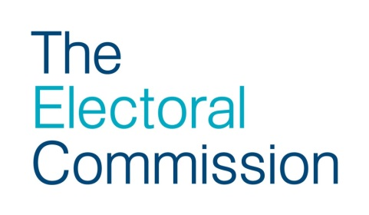

Advice for Presiding Officers on personation
- By the day of the election a Presiding Officer should understand the level of police presence and police response that a polling station may expect.

- Where an incident occurs at a polling place that a Presiding Officer believes may constitute an offence, then they may consider calling the police and asking those involved to await the arrival of a police officer.

- Where there is confrontation, or a reasonable expectation of confrontation, then the Presiding Officer should consider their own safety and the safety of all other people present as a priority.

- In such circumstances, confrontation should be avoided but consideration may be given to other ways of supporting a police investigation, such as:

      - recording a full description of the suspect including their:
        - gender
        - ethnicity
        - colour
        - height
        - any individual or distinctive features including their clothing
        - details of accomplices
      - recording registered numbers of vehicles
      - preserving items touched by a person involved in an incident, if it is safe to do so, until the arrival of a police officer.

- The form on the reverse of this advice may be used to record events.

- If possible, the Presiding Officer should seek corroboration from another person to what they have witnessed, especially the description of the suspect in the event the suspect leaves before police arrival. All written or otherwise made notes should be signed, timed and dated by all staff witnessing the incident.

Statutory questions
Where personation may be suspected, Presiding Officers and poll clerks are strongly advised to refrain from asking anything other than the statutory questions. Asking other questions may constitute an informal interview and jeopardise the possibility of bringing a successful prosecution.
No other questions may be asked of the voter by election staff.
If further investigation is deemed necessary, the matter should be referred to the police.
Statement supporting an allegation of personation

Statement of (print name in block capitals) ………………………………………..

This statement, consisting of …. page(s), each signed by me, is true to the best of my knowledge and I make it knowing that, if it is tendered in evidence, I shall be liable to prosecution if I have wilfully stated in it anything which I know to be false or do not believe to be true.

Dated ………………………. (insert day, month and year)

On ………………………….. (insert day, month and year) I was in attendance

at …………………………………………………….…………… polling station, at

………………………………………………………………………… (address)

in the following capacity:

Presiding Officer/Poll Clerk/Candidate/Agent/Police Officer (please delete as appropriate) or other (please state) ………………………………………….

At …………….. am/pm I/the Presiding Officer asked the person seeking to vote the statutory questions:

1. In response to the first statutory question (regarding the person’s identity being the same as the person named on the register of electors)

The person (who I know/believe to be …………………………………) replied

‘………………………………………………….…………………………………..’

2. In response to the second statutory question (regarding whether the person had already voted other than as a proxy voter)

The person (who I know/believe to be …………………………………) replied

‘…………………………………………………………………………………..…..’

Signature of the person making the statement ……………………………….…..

Witnessed by (signature) …………………………………………………………….

(Print name) …………………….……………………………………………………..

Further comments or personal descriptions may be added on the reverse of this form or on another piece of paper. Please make sure each sheet is signed and witnessed.

