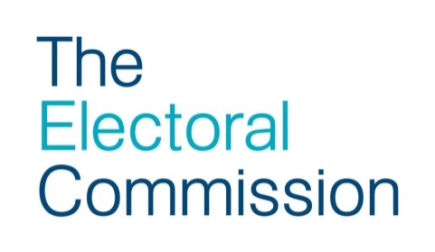

Tellers dos and don’ts
Tellers are usually volunteers for candidates. They stand outside polling stations or polling places and record the electoral number of electors who have voted. By identifying electors who have not voted and relaying this information to the candidate or their supporters, tellers play an important role in elections and referendums. The candidate or their supporters may then contact the voters who have not yet been to vote during polling day and encourage them to vote.

There should be no more than one teller at a polling station for each candidate at any time. Where a polling place contains more than one polling station with separate entrances, it may be appropriate for there to be tellers at each entrance, but no more than one per candidate.

Tellers have no legal status and voters have the right to refuse to give them any information. The Returning Officer or their staff may provide further guidance on the activities of tellers.

Tellers must
- always remain outside the polling station
- only enter the polling station to cast their own vote, to vote as a proxy or to accompany a disabled voter
- always comply with the instructions of the Returning Officer and Presiding Officer

Tellers must not
- be able to see or hear what is happening inside the polling station
- impede, obstruct or intimidate voters on their way in or out of the polling station
- demand any information relating to a voter’s elector number, name or address
- ask to see or check a voter’s photographic ID
- ask voters to re-enter the polling station to ascertain their elector number
- have discussions with voters that may give rise to allegations of undue influence (e.g. voting intentions, party affiliations or party campaigns)
- display any campaign material in support of or against any particular political party or candidate other than a rosette or badge

Tellers may
- approach voters for information in accordance with instructions from the Returning Office and Presiding Officer
- display a coloured rosette or badge displaying the name of the candidate, party and/or emblem or description; the rosette/badge should not bear a slogan and must not be oversized
- remind electors as they approach the polling station that they need to provide photographic ID

