Voter ID Resources – 2026 English local elections

Social media posts
As part of the Electoral Commission’s Voter ID campaign, we have produced graphics which can be used on social media to raise awareness of the need for voters to bring photo ID to vote at a polling station in England. These graphics, and the suggested copy below, can be posted ahead of the Tuesday 28 April application deadline for free Voter ID, and in the run up to the local elections on Thursday 7 May.
We’ve produced assets with the following social platforms in mind:
• X/Twitter – headers and organic content
• Facebook – headers and organic content
• Instagram – organic content and stories
Please find below suggested copy to go with each asset, as well as the suggested platforms and formats.
Please ensure you use the full long links we have provided in the suggested copy. These will aid our analysis of the campaign.

Variant | Example graphic(s) | Suggested Copy | Platforms & format
1: Remember (checklist) | 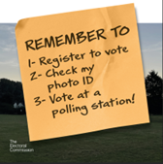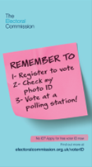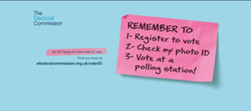 | There are local elections in England on 7 May.  Voting at a polling station? You need photo ID to vote.  Don’t have photo ID? Apply for free voter ID ⬇️  https://www.electoralcommission.org.uk/voting-and-elections/voter-id?utm_source=partner_social&utm_medium=social_media&utm_campaign=voter_id&utm_content=voter_id_home | Landscape: Facebook header, X header  Portrait: Instagram story  Square: suitable for regular post on most platforms (Instagram, Facebook, X, LinkedIn, Bluesky, etc.).
2. You need photo ID | 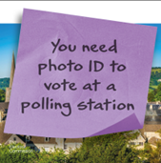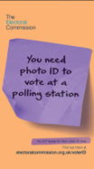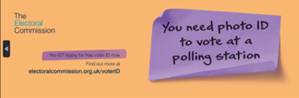 | You will need to show valid photo ID when voting at the local elections in England on 7 May.  No ID? You can apply for free voter ID now.  Find out what is accepted and apply for free voter ID if you need to ⬇️  https://www.electoralcommission.org.uk/voting-and-elections/voter-id?utm_source=partner_social&utm_medium=social_media&utm_campaign=voter_id&utm_content=voter_id_home | Landscape: X header  Portrait: Instagram story  Square: suitable for regular post on most platforms (Instagram, Facebook, X, LinkedIn, Bluesky, etc.).
3. VAC deadline | 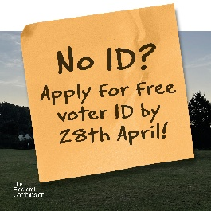  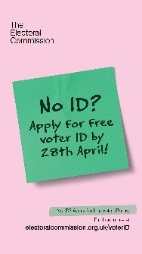  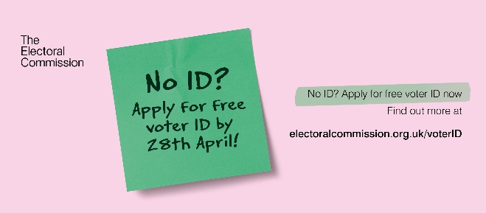 | Don’t forget! 📢  On 7 May there are local elections taking place in England.  You need photo ID to vote at a polling station.  Find out what ID is accepted and apply for free voter ID if you need to ⬇️  https://www.electoralcommission.org.uk/voting-and-elections/voter-id?utm_source=partner_social&utm_medium=social_media&utm_campaign=voter_id&utm_content=voter_id_home | Landscape: Facebook header, X header  Portrait: Instagram story  Square: suitable for regular post on most platforms (Instagram, Facebook, X, LinkedIn, Bluesky, etc.).
4. Forms of ID (static) | 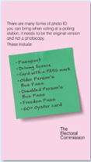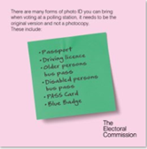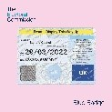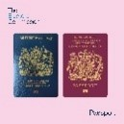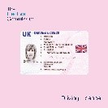 | You’ll need to bring photo ID when voting at the local elections in England on 7 May.  👉 Swipe to see the most common forms of photo ID that will be accepted.  [For Facebook, X and LinkedIn:]  Check out the full list of accepted ID ⬇️  https://www.electoralcommission.org.uk/voting-and-elections/voter-id?utm_source=partner_social&utm_medium=social_media&utm_campaign=voter_id_scot&utm_content=voter_id_home | Portrait: Instagram story  Square: Instagram
5. Forms of ID (gif) | 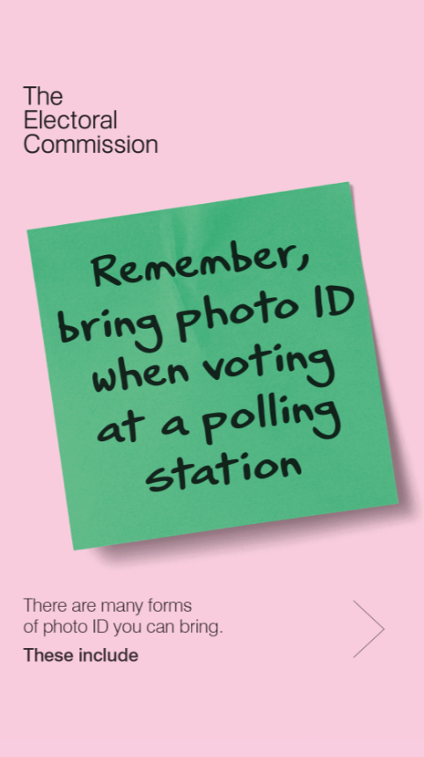 | [No copy needs to be added to the animated gif - a link button to https://www.electoralcommission.org.uk/voting-and-elections/voter-id?utm_source=partner_social&utm_medium=social_media&utm_campaign=voter_id_scot&utm_content=voter_id_home can be added if desirable] | Ideal for Instagram Reels, TikTok or YouTube Shorts. Can also be posted to other platforms.
6. Polling day | 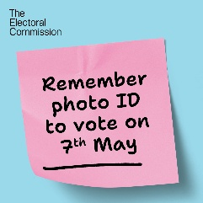  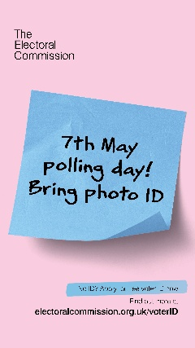  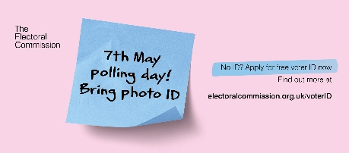 | You’ll need your photo ID to vote in the England local elections today, so don’t forget it!  Check which forms of ID are accepted ⬇️  https://www.electoralcommission.org.uk/voting-and-elections/voter-id/accepted-forms-photo-id | Landscape: Facebook header, X header  Portrait: Instagram story  Square: suitable for regular post on most platforms (Instagram, Facebook, X, LinkedIn, Bluesky, etc.).

