User Guide for Post poll data collection May 2026

Contents
User Guide for Post poll data collection May 2026 1
1. Portal Guidance – 2026 2
2. Introduction 3
3. Logging into the portal 4
4. Voter ID data 2026 May elections 5
5. England core local elections – ward/electoral division data 5
6. Uploading Ward Data 6
7. Filling in data for all elections – Post-poll response 7
8. Frequently asked questions 8
9. Further information 9
10. Setting up your account (only applicable in rare cases). 10

- Portal Guidance – 2026
We’re aware of some technical issues when navigating between categories in the data portal. You can still submit data successfully if you follow the guidance below on how to move between sections of the form.

🛑 What’s the problem?
There are two ways to move between categories in the portal:
- Clicking "Next" at the bottom of the screen.
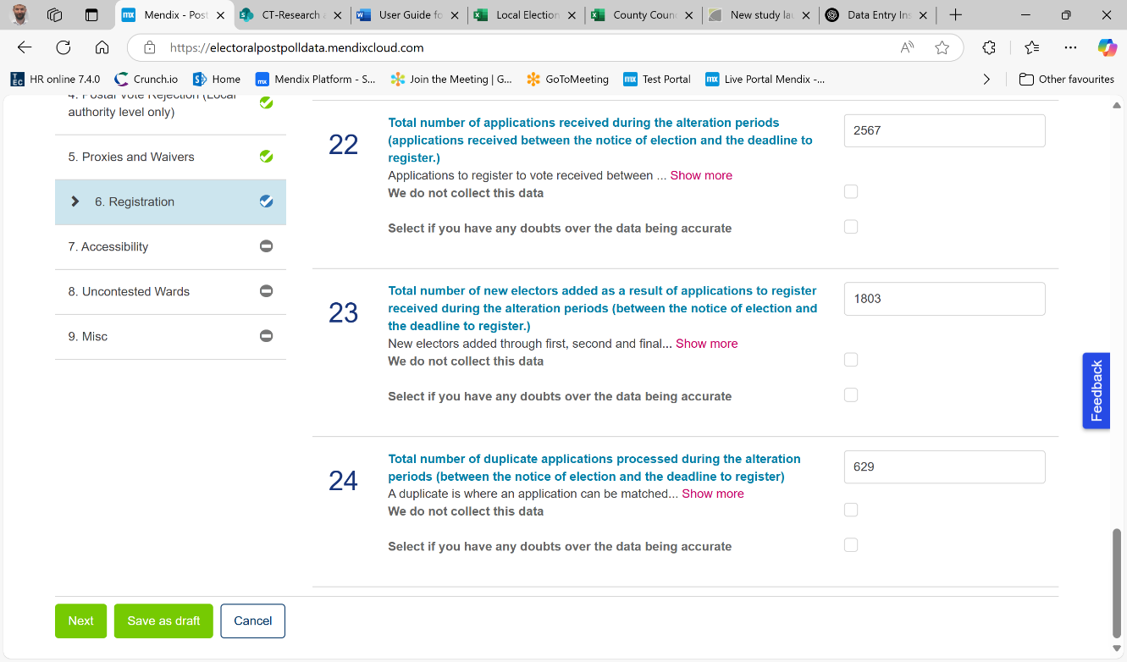
- Clicking the category name in the menu on the left-hand side.
Different categories you can click on to move category

At bottom of screen click to go to the next category

Each method works in different parts of the form. If you use the wrong method, your data might not save or process correctly.

✅ How to navigate correctly:
1. Ward-level questions
(Only applies to County Council or Local Elections in England)
These are the first three categories in the form.
- 👉 Use the "Next" button at the bottom of the screen to move forward.
- ❌ Do not click on the category list on the left — this can prevent ward-level data from being properly totalled.
2. All other questions
(Applies to questions at Local Authority and Constituency level)
- 👉 Use the left-hand menu to move between categories.
- ❌ Do not use the "Next" button — this may cause the system to get stuck on a "Processing" screen.
If it does:
- Wait for up to 10-15 seconds maximum.
- If still stuck, refresh the web page.
- Then log back in, re-enter the portal, and continue from where you left off (your answers will have been saved).
Note if the portal does not work using one of these methods of going to the next category then try the other.

2. Introduction
- The full data we are collecting is here. As always, your EMS provider has been informed of the data we are going to collect
- The collection of voter ID data is entirely optional. If you are collecting data then you are welcome to return data to us via the data portal in the same way you did last year. We will not chase you for this data. If you are going to return data please do so by the 29th May. If you want the VIDEF add up sheet it's here.
- In Scotland and Wales, we are collecting a slightly reduced version of the data we collected for the previous Senedd and Scottish Parliament elections to standardise what we collect with other elections
- In England, we are collecting an additional field on the number of election staff at the local authority level. Otherwise, there have only been minor changes to the data we are collecting.
- The deadline is Friday 29th May for all data collection. We have a tight deadline for reporting after the election so we really need you to be punctual with completing the data (and to answer any data queries quickly). The link to the portal is here. The data you need to fill in will be live from election day onwards so you can complete whenever is convenient.

3. Logging into the portal

Email addresses
- Each Local Authority is registered on the data portal (& linked in most cases to a generic election email address for your local authority). Every local authority should already be registered (unless you have changed your local authority generic email address since the last election) and from the 8th May will just need to click here on the following link to log in.
- Please see the appendix for the list of different email addresses we have down for every local authority. Most go to the generic local authority email address. Note that you might have your personal work email address CC into an email sent from the portal. Note this will not change your username which will remain the primary email recipient (if you open the email the username will be the email address that the email is in the ‘To.’ box)
- For some local authorities their username was changed (before a previous election) to an individual work email address. We have included the name of the person that was set up this way in the appendix. Let us know (email: research@electoralcommission.org.uk) if that person is no longer the key contact and an alternative contact can be set up.
- If you are from a local authority which has not returned data previously via the portal see the instructions on page 9 on setting up an account)

Logging in
- Here is the link to the log in page.
- Your username will be the email address that you have used to access the portal at previous elections (e.g. elections@boroughcouncil.gov.uk). Note it might be the case that multiple different email addresses (multiple aliases) are received into one mail box with a different name for your local authority. We will have set up only one username for each local authority see the end of this guide where all usernames/ email addresses are listed. Note also that if you receive an email through the portal open it and look at the email address in the ‘too box’ this will be your username.
- Forgotten password? From this log-in page you can select ‘Forgot your password’ to create a new password.
- Once you have logged on you will see a dashboard of all the different elections you have which we are collecting data for. If you do not have the right elections then email research@electoralcommission.org.uk.

Elections list
- You will see a list of all the elections on the left of the screen that we are expecting you to return data for. Please check the list of elections is what you are expecting as we will send a reminder for filling in data for these elections until we have received all the data the system is expecting (including for all areas/constituencies).
- Once you select the election you want to fill in data for on the left then on the right select create response.

4. Voter ID data 2026 May elections
Data collection for Voter ID in 2026 is entirely optional for English local authorities. You can return data to us if you want to via the portal but we will not be chasing you to fill out the data if you don’t return it.
If you choose to return data to us we will be collecting the same data as we did last year.
Once again for data collection, we directly reference the fields in the VIDEF.
The only field (around ID) we are collecting not on VIDEF
The only field that we are collecting that is not on the VIDEF is the number of polling station voters on the day (ballot box turnout minus postal votes included in the count). This is important as we need to be able to generate a proportion of voters turned away on polling day.
At what level are we collecting the data
The vast majority of data we want you to report back is at the total local authority level. This requires you to add up the VIDEF fields for each polling station in your local authority.
Collecting data by whether there is a Marshall/ greeter at that polling station
The Voter Identification Regulations require that all VIDEF data is split by whether there was a marshal/greeter at a polling station.
We are requesting data for those polling stations with marshals/greeters and the overall total for all polling stations.
We also need you to tell us the number of polling station voters at polling stations with greeters and in total.
Publishing data
There are no publishing restrictions this year around the publishing of voter ID data.

5. England core local elections – ward/electoral division data
The data we are collecting is very similar to last year with just a couple of things that we collected last year that we don’t need this year.

Confirm wards/ electoral divisions up for election
- On the first screen after you have selected the local election you will need to enter in all the names of the contested Wards/electoral division for this election.
- To begin, click the Add ward button. This opens a dialogue box where you can type the name of a contested ward. Each ward needs to be added separately.
- If you plan to use the data import function (see below), you will need to make sure you add the Wards/Electoral divisions’ names with exactly the same spelling, capitalisation and punctuation as they will appear in the import file (i.e. how they appear in your EMS).
- On the screen it will only show 20 wards at a time so if you have more than that you will need to use the arrows at the top right of the list to toggle.
- At the top of the list of wards there is an option to Search, Add ward, edit selected ward and delete selected wards.
- Once you have finalised the list click continue at the bottom of the page.

6. Uploading Ward Data
Whether you are uploading data or entering it directly please do not add the total local authority figure for these ward-level categories. This total figure will auto calculate from the ward / electoral division data you provide. Please do check that the total local authority numbers which appear match your records and have a look at your ward / electoral division data to see if any amends are needed.

Providing ward/division data – Civica and Democracy Counts users
- If your EMS provider is Civica or Democracy counts then your system should be set up to generate a file designed to be imported to the portal. This file will contain headings for each of the data categories we are requesting and rows for each of your wards.
- Where the EMS holds data it will populate an excel file with the correct figures. The system can only generate data which you have previously inputted to the EMS. For example if you do not enter data on the number of postal votes at the count into your EMS the system will not be able to include it in the file. However, you will be able to manually add these numbers to the excel file before uploading (this is what we recommend that you do).
- To upload the EMS input will need to save the Excel file to your computer. Click on Upload Ward Answers and then select the excel file you want to upload.

Providing ward data – all other users
- Where you cannot generate a file from your EMS we still recommend that you compile the ward data by completing it in a correctly formatted excel file and then uploading it to this portal.
- A blank template can be found here. This template is correctly formatted for upload – please do not amend the heading or any of the formatting. For example, if you are copy and pasting data into the file do not include formatting such as thousand separators (e.g. 1,000).
- In the first column put the ward name. Make sure the name matches exactly what you selected as your ward names on the first screen (include punctuation & capitals)
- To upload it you will need to save the Excel file to your computer. Click on Upload Ward Answers and then select the excel file you want to upload.

All users
- Please note we are aware that the import function or moving between the ward data pages is not as quick as we would like it. Depending on how many wards/ electoral divisions you have will depend on how quick it will be. You will need to allow time for the import to happen/ to change page. Using the import functionality will still be the quickest way to provide the data.
- Please check the data once you have imported it to make sure that it is correct. There are 2 views you can use to review the data.
- On the main ‘Post-poll response’ page you will be able to see your imported responses. It will have imported all the data for all the relevant fields. Where relevant it will show key calculations which can be made with the data you import for us.
- If you select View ward data then you will see all your ward/ electoral division data in one place in a grid. Where the data you have entered has failed a validation check then you will see the data surrounded by two # symbols. If you click on that number it will tell you any calculation that can be made with it and why it is failing the validation check.

7. Filling in data for all elections – Post-poll response
- There are a maximum of 8 different question areas overall depending on the election type (as shown in the grid in section 1 above).
- You can fill in the questions in any order you want. You can click on the category names on the left-hand side of the screen to change categories it will automatically save what you have entered when you go to a new page.
- For all fields you have the option to: Select if you have any doubts over the data being accurate. If you select this please explain in the open text box provided what makes you unsure about the data. Note we are not using this to assess the performance of local authorities but to understand how we need to treat the data in any calculations we make from it.
- For some fields you will have the option to say that: you do not have the data. Please tell us why you do not collect this data in the text box that will appear.
- If you want to log out at any stage just click on ‘Save as draft’ at the bottom of the ‘Post-poll response’ screen.
Logic Checks
- There are logic checks to ensure that all answers are valid. Next to the category names on the left hand-side a tick or cross will be displayed showing whether it’s passed the logic check (this will only happen once you click next). If you then click back on this category it will tell you below the answer box why it failed the check.
- Note once you have corrected the data then the red text telling you that there has been a mistake will only disappear once you have gone to the next category (assuming you put in a valid response).
- If you think you have a legitimate answer which is deemed illegitimate please contact the electoral commission at research@electoralcommission.org.uk

Submitting the data
- When you have entered all the requested data (or indicated that you cannot provide it) and it has passed all the logic checks a new option will appear to ‘Finalise Data Submission’.
- When you click to finalise data submission a summary page will appear showing the data you have entered.
- If you scroll down on the summary page you will have the option to submit data.
- Once you have submitted data you will go back to the Post Poll response dashboard and have the opportunity to fill out for any other constituencies you might have.

8. Frequently asked questions

I can’t find an email from the portal?
Note you will receive an email from the portal about data collection on the Friday 8th May asking you to return data to us by the Friday 29th May.
You can check the emails that we are sending data to at the end of this document. Note where we just include the name then this is where we are sending it to their personal local authority email address.
If you still can’t find the email then check your junk mail and if you still can’t find it email research@electoralcommission.org.uk.

When can I fill in the data?
As soon as you have the data. You don’t have to fill all the data in one go, the platform will save your responses. You will receive periodic email reminders until the full dataset has been submitted.

When is the deadline for data submission?
The deadline for submitting all data is Friday 29th May.
If you are choosing to submit Voter ID data, the dedline for this is also Friday 29th May
Why have I received an email saying my data has been rejected?
The email should tell you for what reason the data has been rejected. It will include a link for you to click on to login to the portal. You will then need to resubmit your data to us even if you are reconfirming your previous answers (you won’t need to re-enter the answers).
Why do I keep getting reminder emails?
You will receive a reminder until you have submitted data for your relevant May elections. You will continue to receive reminders until you have filled in all elections data. If you think you have completed all the data that you need to but are still getting reminders please contact us at research@electoralcommission.org.uk. Note you will not receive reminders for the electoral data.
I’ve submitted data – why do I still get reminders? (only applicable to constituency elections)
You will continually get reminders until the data has been submitted for all constituencies in your local authority. Even if you fill in data for one election you will still get reminders until data is submitted for all elections and all constituencies. The same is true if you have submitted voter ID data you will still get a reminder to produce core data.
Can I send my data in another format for the Electoral Commission to enter in the portal?
No, we will not accept the data in any other format. You will need to enter in the data for all the elections that your local authority is responsible for.
How do I go back to the portal to fill in any outstanding data?
Here is a link or you will find the link on the data collection section of the website.

9. Further information
If you have any problems using the system or any questions not answered by this user guide. Please contact us at research@electoralcommission.org.uk or by phone at 020 7271 0611.

10. Setting up your account (only applicable in rare cases).
- You will receive a registration e-mail
A few local authorities might have had their accounts reset so would need to register for the first time
- You will receive an email your local authority election email address (see from page 11-15 for the list of generic email addresses that we are sending emails) from research@electoralcommission.org.uk.
- To create your account please click on the link in the email.
- Note that if you have not received an email it could be in the spam/ junk email address (of your election services email address).
- If you have not received the email then then please email research@electoralcommission.org.uk

2. Setting up a password
- You will be asked to set up a password for your account. Note the complexity requirement for the password specified on the page.
- Please note: If others in your department need access to the system please share the password details with them.

